Project Title: Social Media Platform
Course Name: Web Development (CMPS 350)
Group Members:
- Mohammed Alromaihi 202002029
- Abdulla Alhajri 201901728
- Saoud Almehsen 202001760
- Nasser Nasser 202205729
Project Overview
This project presents the development of a front-end social media platform like applications such as Twitter and Instagram. The system allows users to register, log in, create posts, interact with other users, and manage their profiles.
The platform was built using HTML5, CSS3 (Flexbox and Grid), and Vanilla JavaScript, without using any external libraries or frameworks, as required. All data, including users, posts, likes, and comments, is stored locally in the browser using local Storage in JSON format, ensuring persistence across sessions.

Features Checklist

Feature | Status | Notes
User Registration & Login | ✅ Implemented | Users stored in localStorage
News Feed | ✅ Implemented | Shows posts (recent & following tabs)
Create Post | ✅ Implemented | Posts appear instantly without reload
Delete Post | ✅ Implemented | Only users can delete own posts
Like System | ✅ Implemented | Like/unlike with count update
Comment System | ✅ Implemented | Comments saved per post
User Profile Page | ✅ Implemented | Shows user info and posts
Edit Bio | ✅ Implemented | Only profile owner can edit
Follow/Unfollow Users | ✅ Implemented | Updates followers/following
Search User | ✅ Implemented | Navigate to user profile
Data Persistence | ✅ Implemented | Using local Storage

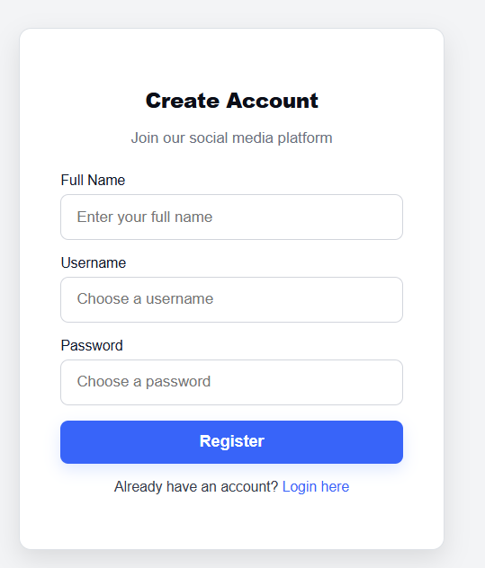
How to use the Application

1. Register a New User
- Open register.html
- Enter full name, username, and password
- Click Register
- You will be redirected to the login page

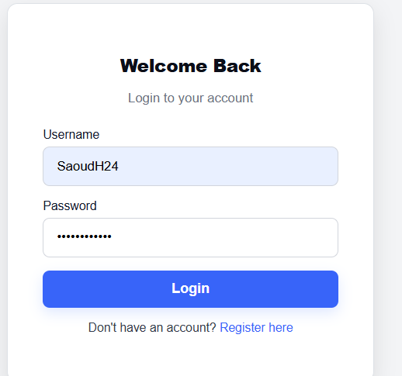
2. Log In
- Open login.html
- Enter your username and password
- Click Login
- You will be redirected to the home page (news feed)

3. Create a Post
- In the home page (index.html)
- Write text inside "What's on your mind?"
- Click Post
- Your post will appear immediately at the top

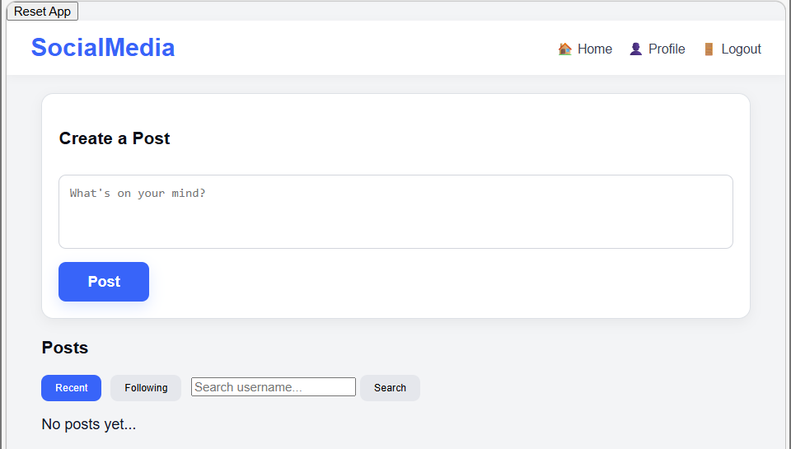

4. Like and Comment on Posts
- Click ❤️ Like to like/unlike a post
- Click 💬 Comments to open comments
- Write a comment and click Post
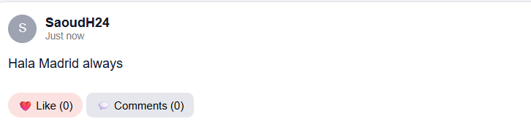

5. Switch Feed
- Click Recent → shows all posts
- Click Following → shows only followed users’ posts
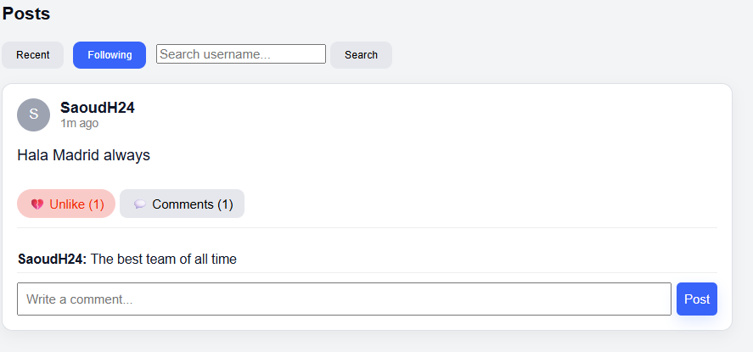

6. View Profile
- Click your username or go to Profile page
- You will see:
  - Username
  - Bio
  - Posts
  - Followers / Following count
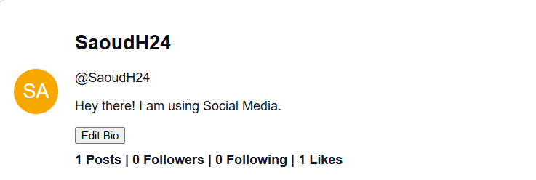

7. Delete a Post
- Go to your profile
- Click Delete on your post
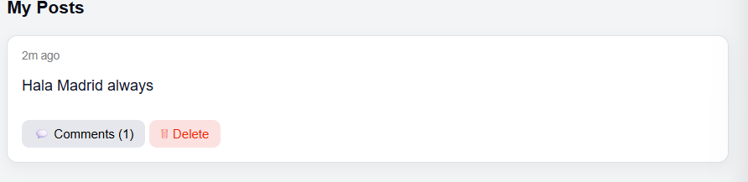

Project Links
GitHub Repository: https://github.com/Sa2001760/Web-dev-project-04.git

